Standards and Quality Report
2022/23
The Meadows Private Day Nursery Ltd
Where Young Minds Grow

Introduction
The Meadows Private Day Nursery was opened in February 2017. It is a small open plan setting providing care for a maximum of 37 children aged 0-12 years of age at any one time.
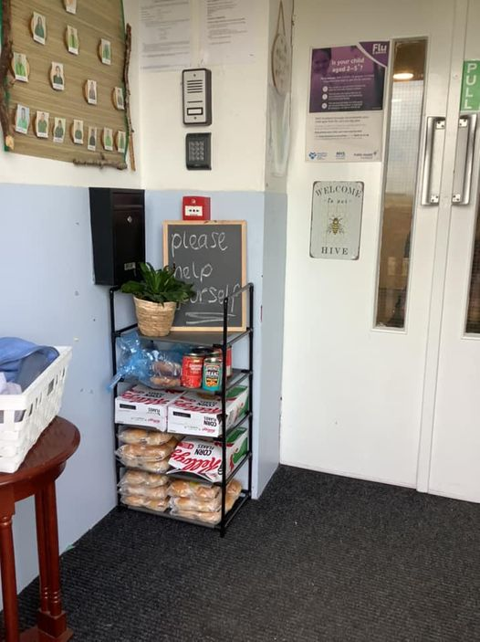
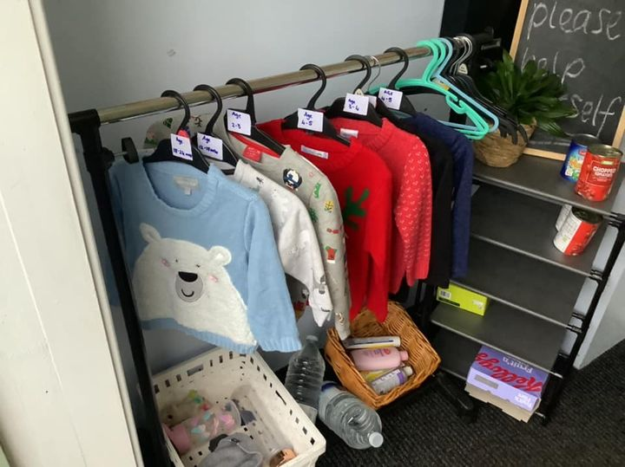
Vision
Community litter pick, October 2021
Community Larder introduced, November 2021
Christmas jumper swap shop, November 2021
Reintroduction of home links, January 2022
Our vision is to grow healthy and happy children by providing a safe and stimulating environment for children aged 0-12 years encompassing a wide range of age-appropriate activities and experiences within our indoor and outdoor areas. We foster positive relationships with children through nurturing, responsive care as well as with parents and carers, recognising the importance of strong partnerships between home and nursery. We aim to provide opportunities to improve outcomes for all children through promoting the rights of all our children in a respectful manner, ensuring they reach their full potential as Successful Learners, Confident Individuals, Effective Contributors and Responsible Citizens. As we are a small service, we aim to do this by creating a warm, welcoming home from home environment.

Values
- Dignity and respect
- Compassion
- Inclusion
- Responsive care and support
- Health and well being

Aims
To achieve our vision, we will work in close partnership with the children and their families to ensure that we meet their needs effectively through regular consultation and review. At present this is mainly done remotely via our online system Famly but we have reintroduced in person meetings where appropriate. We offer parents flexibility with regards to meeting their childcare needs through a booking system and the children’s needs are monitored and reviewed using the relevant curriculum framework documents Pre Birth to 3 and the Curriculum for Excellence as well as Realising the Ambition, Getting it Right For Every Child (GIRFEC) and How Good is our Early Learning and Childcare (HGIOELC).

Context of the early years centre
The Meadows Private Day Nursery is registered with the Care Inspectorate for a total of 37 children at any one time. This includes 6 spaces for children under 2 years old as well as 6 spaces for school aged children. Since opening in 2017 we have supported more than 200 children. From our last unannounced inspection in May 2018, we were graded –
Quality of care and support 4 - Good
Quality of environment 4 - Good
Quality of staffing 4 - Good
Quality of management and leadership 4 - Good

The nursery is located on the main B743 road which runs through the village of Mossblown. We provide care for families from the neighbouring villages of Tarbolton, Annbank, Mauchline and Ochiltree as well as the town of Ayr. Mossblown is part of the Ayr North and former Coalfields communities’ locality (ANFCC).
For the most recent time periods available, Ayr North and Former Coalfield Communities had:
- 12% of Mothers exclusively breastfeeding at 6-8 week review.
- 26% of Mothers smoking during first antenatal booking appointment.
- 50% of Teenage Pregnancies in Under 20s
- a 98% uptake of 6 in 1 Immunisation for the eligible population.
- a 96% uptake of 24 months MMR Immunisation for the eligible population
- 68% of Primary 1 Children with no dental caries
- 75% of Primary 1 children with healthy weight
- 0% of people lived in the least deprived SIMD quintile, and 59% lived in the most deprived quintile.

Table 1: Percentage population living in the 2016 and 2020 SIMD Datazone Quintiles

Quintile | Percent of Pop (2016) | Percent of Pop (2020) | Difference
SIMD 1 | 58.3% | 58.7% | 0.4%
SIMD 2 | 27.3% | 23.4% | -4.0%
SIMD 3 | 14.3% | 17.9% | 3.6%
SIMD 4 | 0.0% | 0.0% | 0.0%
SIMD 5 | 0.0% | 0.0% | 0.0%

The nursery is situated between the local schools and early years centres in Mossblown and Tarbolton. We can provide wraparound care for children attending these schools. As such we have good professional relationships with them and plan appropriate transition activities and celebrations for example during June for P1 transitions. We also have children transitioning to St John’s, Dalmilling, Ochiltree and Struthers primary schools this year.

As of August 2019, we offer funded childcare to all 3 and 4 years old as well as eligible 2 years old on a flexible basis to suit the needs of families. This year we have had 6 ante pre-school children and 9 preschool aged children take up this offer. From these 9 preschool children we have achieved successful outcomes as detailed in the table below.

 | 2022 | 2021
% Achieved all milestones in communication | 57% | 57%
% Achieved all milestones in numeracy | 57% | 57%
% Achieved all milestones in health and well being | 100% | 100%

January 2020 saw us expanding our service to enable us to deliver care and learning to under two years in their own separate area which in turn enabled us to better meet the needs of all our children and close the attainment gap as per the National Improvement Framework. This also enabled us to reinstate our before and after school care service. This year we have been able to successfully retain our 100% achievement in health and wellbeing. This is due to us being a small service, we are able to offer the children a nurturing home from home environment in close partnership with our families. This is also aided by our low staff turnover. We also employ local people with local knowledge. This enables our families to relax and share more openly which in turn means we have a better understanding of the children’s wellbeing needs. This year has seen us successfully take on our first modern apprenticeship. Tygan John lives in the neighbouring village of Annbank and is now going on to further her career by attending UWS to train to be a teacher.

Referrals from external agencies can also be accommodated via a request for assistance procedure to offer families much needed support and respite. Since opening we have supported approximately 13 children through this system.

2021-22 has seen us continue to work with COVID-19 guidelines to keep our children, families and staff safe. Thankfully we are now able to return to a bit more normality which has seen us reintroduce home links.

The building has 3 rooms to enable the children to develop and learn in a safe age-appropriate area. The Nest for approximately ages 0-2½, The Hive for approximately 2½-5 years and our smaller room The Burrow that houses our before and after school care. The setting cares for children from 7.30am until 6pm and offers a drop off and pick up service from Annbank and Tarbolton Early Years Centres and Primary schools. There is a quiet area off The Nest to allow those children who require a rest during the day to do so without being disturbed by the day’s hustle and bustle. To meet the differing toilet needs of the children there is a separate changing room and children’s toilet with all amenities at the children’s level to encourage independence and privacy. We have a large, secure outdoor area at the rear of the building that the children access daily. Each room has access to a covered area so that the garden and outdoor play can be enjoyed year-round.

Early 2022 saw us starting to welcome back our 3 staff members from maternity leave. All staff within the nursery are qualified to or are working towards their SCQF level 7 award in early years. Senior staff are also working towards their SCQF level 9 qualifications. From the total staff team, the manager is BA qualified, 1 senior is working towards her BA, 4 seniors or acting seniors are working towards their SVQ level 9, 1 practitioner is SVQ level 9 qualified, with the rest of the practitioner team being level 7 qualified. In August 2022 our first Modern Apprentice successfully completed her level 7 and progressed to UWS for teacher training. All staff members have annual supervision and appraisals which helps to identify areas for improvement that they can access to help meet their SSSC PRTL requirements. In line with our partnership agreement with South Ayrshire council we have a peripatetic teacher supporting the children’s learning.

Staff meet the developmental needs of all the children through fun activities following In The Moment Planning. This sees them carrying out focused observation of the children and consultation with them to ensure everything is appropriately geared towards their needs and interests. Parents receive regular updates on their child’s progress through our online daily diary via an app called Famly as well as individual reviews carried out at no longer than 6 monthly intervals. An open-door policy is in operation to discuss anything at any time.

What key outcomes have we achieved?

School Priority
To develop and implement Literacy strategies that will impact on children’s overall attainment in this area. 65% of children reaching their pre-school developmental milestones in literacy
Looking at:
Breadth
Challenge
Application
To improve rhyme and awareness of syllables.
NIF Priority:-  - Improvement in attainment, particularly in literacy and numeracy  - Closing the attainment gap between the most and least disadvantaged children  - Improvement in employability skills and sustained positive school leaver destinations for all young people | Links to HGIOELC QI:-  2.3, 3.2
Progress and Impact
57% achieved all their developmental milestones before starting school in August 2022
Next Steps
To develop and implement Literacy strategies that will impact on children’s overall attainment in this area with 60% of children reaching their pre-school developmental milestones.
Looking at:
  - Breadth
  - Challenge
  - Application
To improve phonological awareness to include rhyme and syllables

School Priority
To develop and implement Numeracy strategies that will impact on children’s overall attainment in this area. 65% of the children being able to use mathematical language.
Looking at:
Breadth
Challenge
Application
Pattern, 2D shapes, 3D shapes, and mathematical language in everyday context.
NIF Priority:-  - Improvement in attainment, particularly in literacy and numeracy  - Closing the attainment gap between the most and least disadvantaged children  - Improvement in employability skills and sustained positive school leaver destinations for all young people | Links to HGIOELC QI:-  2.3, 3.2
Progress and Impact
57% achieved their developmental milestones before starting school in August 2022
Next Steps
To develop and implement Numeracy strategies that will impact on children’s overall attainment in this area with 60% of children reaching their pre-school developmental milestones.
Looking at:
  - Breadth
  - Challenge
  - Application
Subitising, 2D shapes, 3D shapes, and mathematical language in everyday context.

School Priority
To develop and implement Health and Wellbeing strategies that will impact on children’s overall attainment in this area. 100% of children reaching their pre-school developmental milestones in health and wellbeing.
100% of children’s awareness of target – ‘I can show I understand that eating more of some types of foods and less of others is good for health’
Looking at:
Breadth
Challenge
Application
Support and encouraged the children’s knowledge and understanding of where food comes from and what constitutes a healthy lifestyle across the whole nursery.
NIF Priority:-  - Closing the attainment gap between the most and least disadvantaged children  - Improvement in children and young people's health and wellbeing  - Improvement in employability skills and sustained positive school leaver destinations for all young people | Links to HGIOELC QI:-  2.3, 3.1, 3.2
Progress and Impact
100% achieved their developmental milestones before starting school in August 2022
Next Steps
To develop and implement Health and Wellbeing strategies that will impact on children’s overall attainment in this area.
Looking at:
- Breadth
- Challenge
- Application
Support and encouraged the children’s knowledge and understanding of where food comes from and what constitutes a healthy lifestyle as well as how to prepare and cook healthy meals and snacks.

Evaluation Summary

Quality Indicator | School Self Evaluation  (Please add 3 or 4 evaluative statements linked to the themes)
1.3  Leadership of change  Developing a shared vision, values and aims relevant to the school and its community.  Strategic planning for continuous improvement.  Implementing improvement and change | Our vision was updated last year in consultation with the staff team, our parents, and carers as well as the children who attend our setting. It has a strong focus on outdoor learning as well as reducing our impact on our wider environment.  To set our annual priorities, we take account of the data gathered from our milestones. As well as local inspection reports and national priority reports. This is then embedded within our planning for learning for staff and children whilst taking account of individual needs and preferences. This can be seen in our online learner profiles.  All staff are included in implementing change by being allocated areas for them to improve. They are guided and supported by senior staff members and relevant training is sought where appropriate. We are currently enhancing our outdoor provision to support our children who have had a negative beginning due to COVID mitigations and not getting out and about to meet up with others.
2.3  Learning, Teaching and Assessment  Learning and engagement  Quality of interactions  Effective use of assessment  Planning, tracking and monitoring | Child centred approaches are extremely evident, staff know the children and their families well. Observations are used to enable the staff to design play areas (inside and out) to meet the varying needs and are met through the pace of the day. We have introduced the UNCRC across the playrooms and this will be further enhanced next year.  Staff have a vast knowledge of the children and their families. This has enabled the staff to build positive relationships with them resulting them going the extra mile to support children and their families. The pace of the day is dictated by the children, they have free flow inside and out, ITMP is used to meet the children’s interests and developmental milestones.  Staff are very knowledgeable on the children’s needs and interests. This information is used to inform room layout and experiences offered. Previous progress achievements are looked at to inform next steps. Other professionals are involved where appropriate to support children’s progress and to identify and support individual needs.  Key workers have diaries, notebooks etc in order to organise their children, their interests and how to reach their milestones.
3.1  Ensuring wellbeing, equity and inclusion  Wellbeing  Fulfilment of statutory duties  Inclusion and equality | Staff members are aware of the children in their care and how to meet their developmental needs. Staff contact health visitors and schools for successful transitions for P1. We have introduced a food larder where those in need can collect useable food to challenge the poverty gap. Children are actively involved in setting golden rules and checklists to ensure the setting is looked after and everyone is safe and healthy.  All children have a child centred care plan in place that is reviewed within 6 months. All staff members are registered with the SSSC and are aware of and working towards their PRTL requirements. Annual appraisals are carried out as well as following the national induction document to ensure staff are aware of their obligations. Annual child protection training is carried out.  Staff members are knowledgeable of our children’s family backgrounds (whilst maintaining confidentiality). Positive relationships are in place with parents and named people. Those children who come via RfA and/or have social work involvement staff attend TAC meetings etc to ensure the children can access the relevant support they require.
3.2  Securing children’s progress  Progress in communication, early language, mathematics, health, and wellbeing  Children’s progress over time  Overall quality of children’s achievement  Ensuring equity for all children | Children are progressing well across the nursery. Numeracy skills have been developed across the board. Our milestone data has remained the same as last year; 100% in health and wellbeing as well as 57% for literacy and numeracy.  Our milestone data is accurate and in line with local expectations. Our achievement levels have been consistent since starting our partnership agreement. Children move on from us successful, confident learners.  Home learning bags have been introduced, talk boxes are being used. A wow wall has been introduced to share achievements from home. Achievements need to be recognised and celebrated more within the setting.  Staff members are building up positive relationships with those children and families who are accessing our service via a ‘request for assistance’. This encourages positive wellbeing outcomes for the wider family.

What are the key priorities for improvement in 2021/22
Priority 1: -
Raising attainment and achievement in Literacy, closing the poverty related attainment gap
To develop and implement Literacy strategies that will impact on children’s overall attainment in this area with 60% of children reaching their pre-school developmental milestones.
Looking at:
- Breadth
- Challenge
- Application
To improve phonological awareness to include rhyme and syllables.

Priority 2: -
Raising attainment and achievement in Numeracy, closing the poverty related attainment gap
To develop and implement Numeracy strategies that will impact on children’s overall attainment in this area with 60% of children reaching their pre-school developmental milestones.
Looking at:
- Breadth
- Challenge
- Application
Subitising, 2D shapes, 3D shapes, and mathematical language in everyday context.

Priority 3: -
Raising attainment and achievement in Health and Wellbeing, closing the poverty related attainment gap
To develop and implement Health and Wellbeing strategies that will impact on children’s overall attainment in this area.
Looking at:
- Breadth
- Challenge
- Application
Support and encouraged the children’s participation in the veg garden. This will help the children to follow rules and share with their peers as well as preserve in completing tasks from planting to harvesting their own produce.

What is the capacity for improvement?
As a growing setting we are constantly making improvements to our indoors and outdoors environments whilst maintaining a high standard of care and support. We are moving away from plastic limited resources to more natural and inviting ones. The Spring of 2021 saw us successfully apply and be granted a variation to increase our overall numbers slightly which will enable us more flexibility to meet the individual needs of our children. As such we have named our rooms The Nest, The Hive and The Burrow. This means we no longer look at our rooms as age categories and more needs based for the children using the rooms. Since opening we have maintained a stable management and staff team with a wealth of experience in various care and training backgrounds. We have had a few maternity posts being covered by our local HNC students from the previous academic year. The new year of 2022 will see us welcome back our staff from maternity leave which in turn will mean a slight staff restructure. As we have been open for a few years now we want to revise our values, aims,

and objectives in partnership with our families. After our Modern Apprentice successfully achieved her level 7 qualification and has moved onto university, we will look at employing another candidate this year.

