
The Meadows Private Day Nursery Ltd
Where Young Minds Grow



IMPROVEMENT PLAN: 2026-2027

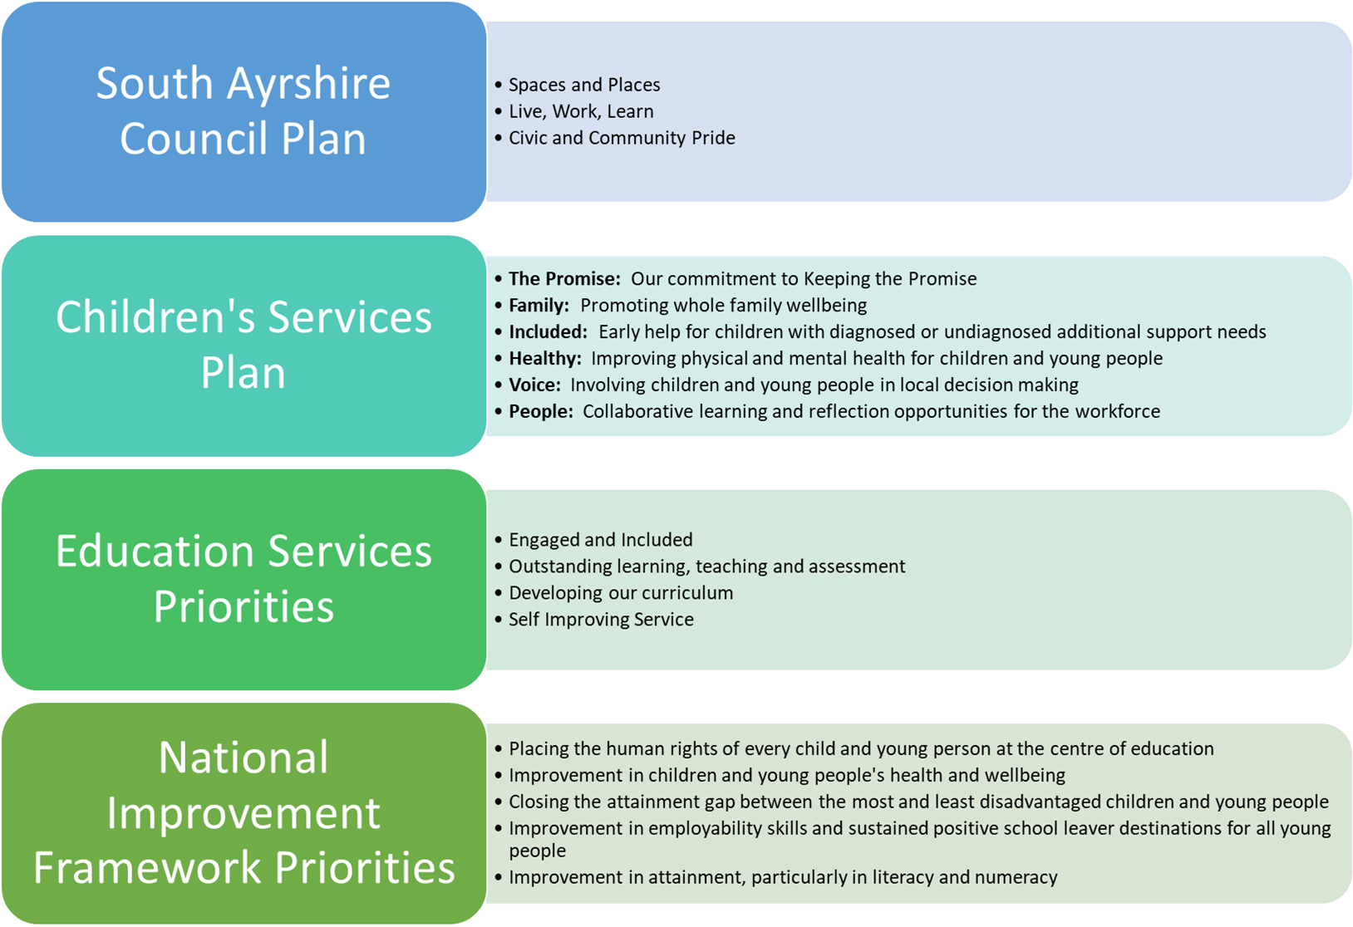
Vision
The aim of our service is to grow happy, confident children that will make a positive impact in our world.

Before a child starts, the manager and staff team work in close partnership with the family to gather and act on all relevant information. Initial visits and settling-in sessions take place in person. An initial care plan is completed within 28 days of the child's start date, reviewed whenever needs change and formally updated at least every six months in consultation with the child and family. Staff monitor and review each child's needs using the relevant curriculum framework documents. Where possible, the service offers families flexibility through its booking system and allocation of funded hours.

Values
  - Dignity and respect
  - Compassion and kindness
  - Inclusion and engagement
  - Responsive care and support
  - Health, happiness and well being

Aims
To achieve our vision, we will work in close partnership with children and their families, using regular consultation and review to meet individual needs effectively. Most communication takes place through the Learning Journals online system, supported by in-person meetings at least twice each year.

The vision, aims and values have been drawn up in consultation with children, families and staff to ensure they are relevant and meaningful to those concerned.
Progress will be reviewed monthly by the accountable lead and formally evaluated at the end date for each action. Reviews will record the baseline, target, current result, evidence source, status and any corrective action required.

Priority 1: Stimulating and responsive learning environments
Education Services Priorities - Outstanding learning, teaching and assessment
What Outcomes Do We Want To Achieve? | How Will We Achieve This?  (Intervention Strategies) | Lead Person | Start and Finish Dates | How Will We Measure Impact On Children and Young People?  (Include Where Possible Current Measure and Target)
By Spring 2027, all learning environments will meet the agreed SAC audit standard and provide stimulating and responsive play-based learning both indoors and out. Evidence will show that children access resources independently, make choices and sustain engagement during play. | - Review and enhance all learning environments to ensure they are stimulating and responsive to children's interests using SAC audit tools. | Senior staff, PT | Aug 26 – Jun 27 | Complete a baseline SAC audit in August 2026 and repeat the audit in June 2027.
 | - Invest in high-quality, open-ended resources that promote creativity, problem-solving and sustained play. Replace or enhance low-value resources with open-ended, natural and loose-part materials. | Senior staff, PT | Aug 26 – Jun 27 | Use learning walks and observations to assess whether children independently access resources and make choices about their learning.
 | - Increase opportunities for children to access natural, authentic and loose-part materials. Develop more inviting learning spaces that promote curiosity and independence. Introduce new provocations and invitations to play. | Senior staff, PT | Aug 26 – Jun 27 | Use quarterly learning walks from August 26 to June 27 to record children's engagement and sustained involvement during play. Establish the baseline in August, agree the June target and document examples showing that learning environments reflect children's interests, ideas and current learning.
 | - Train practitioners in effective pedagogy and sustained shared thinking so that they use environments, resources and interactions to extend children's learning. | Senior staff, PT | Aug 26 – Jun 27 | Complete a baseline observation of practitioner interactions before training and repeat observations quarterly until June 27.

Priority 2: Staff induction, appraisal and professional learning
Education Services Priorities - Outstanding learning, teaching and assessment
What Outcomes Do We Want To Achieve? | How Will We Achieve This?  (Intervention Strategies) | Lead Person | Start and Finish Dates | How Will We Measure Impact On Children and Young People?  (Include Where Possible Current Measure and Target)
By August 2027, all staff will have an up-to-date appraisal and/or induction record identifying their knowledge gaps and agreed development actions. New staff will complete the job-shadowing induction tool and National Induction resource within the agreed induction period, and staff will evidence how completed training has improved their practice. | - The manager will draw up a new job shadowing induction tool that new members of staff will work their way through with senior team leaders as well as the National Induction resource booklet. | Manager | Sep 26 – Dec 26 | By December 2026, the job-shadowing induction tool will be approved and in use. For every new starter, record the induction start date, monthly review dates, completed sections and final sign-off; monitor completion rates and address any overdue actions at the next monthly review.
 | - The manager will meet new starts monthly to go through induction paperwork and all other staff annually to carry out their appraisal. | Manager | Sep 26 – Aug 27 | Maintain a review log showing that every new starter receives a monthly induction meeting and every established member of staff receives an annual appraisal by August 2027. Record attendance, agreed actions, completion dates and any follow-up required.
 | - Staff to participate in online training using the training list provided on the office wall and identified training needs as well as any other courses suggested by the manager. | Manager | Sep 26 to Aug 27 | By August 2027, every member of staff will have completed a variety of suggested training courses. For each a CPD evaluation will be completed identifying the perceived benefit of the course.

Priority 3: - Vision, values and curriculum rationale redesign
Education Services Priorities – Self Improving Service
What Outcomes Do We Want To Achieve? | How Will We Achieve This?  (Intervention Strategies) | Lead Person | Start and Finish Dates | How Will We Measure Impact On Children and Young People?  (Include Where Possible Current Measure and Target)
By December 2026, the nursery's vision, values and curriculum rationale will be reviewed and revised using documented feedback from children, families and staff. The final versions will identify the consultation undertaken, the themes raised and the changes made in response. | - The manager will reshare the current vision, values and curriculum rationale with all stakeholders and ask for feedback. | Kirsty | Sep 26 – Oct 26 | Issue the current vision, values and curriculum rationale to stakeholders in September 2026. Analyse responses by the end of October 2026 and document the feedback.
 | - Give all stakeholders questionnaires to gain everyone’s views of what they see as the nursery’s priorities. | Kirsty | Oct 26 – Nov 26 | Issue the stakeholder questionnaire in October 2026, record the number invited and the number responding in each stakeholder group. Analyse responses by the end of November 2026 and document the priority themes raised.
 | - The manager will rewrite the current vision, values and curriculum rationale with all stakeholders’ feedback considered. | Kirsty | Nov 26 – Dec 26 | By December 2026, complete and approve the revised vision, values and curriculum rationale. Keep a consultation summary showing how feedback informed each change, share the final versions with all stakeholder groups and record any final responses.

