

Standards and Quality Report

2025/26

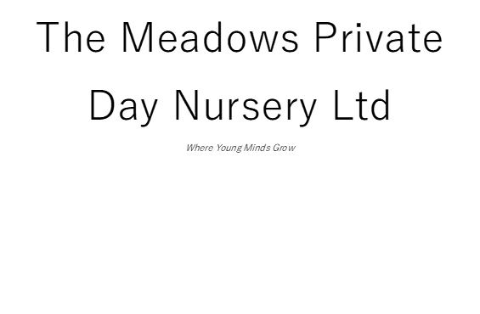

Introduction
The Meadows Private Day Nursery was opened in February 2017. It is a small open plan nursery providing care for a maximum of 37 children aged 0-12 years at any one time.
Supporting local charities Dec 2025

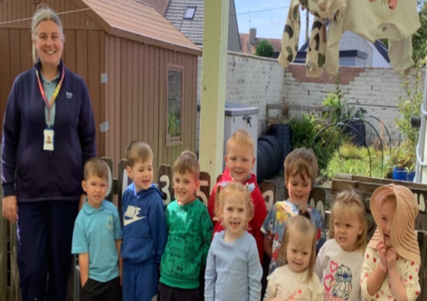
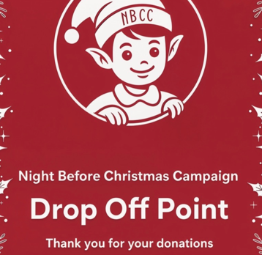
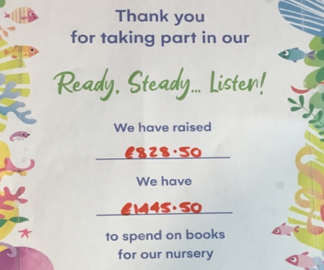
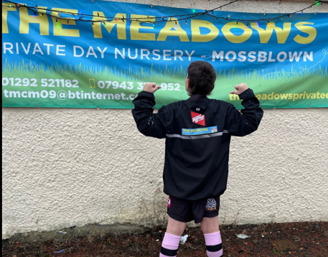
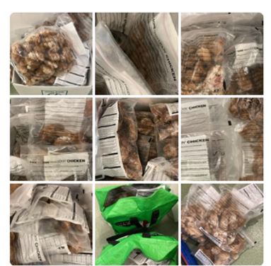
Maintaining high standards with Childsmile
September 2025
Raising money for books September 2025
Supporting local youth rugby
January 2026
Continuing to grow our food donations to combat food waste
July 2026

Vision
Our vision is to grow happy, confident children that will make a positive impact in our world.

We bring our vision to life by providing a safe, secure and nurturing environment where children feel valued, supported and encouraged to thrive. Natural elements are incorporated throughout the nursery wherever possible, helping to stimulate curiosity, inspire exploration and promote meaningful learning experiences. Strong relationships with families are at the heart of our approach. Before a child joins the nursery, we gather and carefully consider all relevant information to ensure we fully understand their individual needs, interests and circumstances. This enables us to provide personalised care and support from the very beginning. We offer individualised settling-in visits and sessions prior to a child’s start date, allowing children and families to become familiar with the nursery at a pace that suits them. Initial care plans are completed within 28 days of enrolment and are reviewed regularly in partnership with children and families. Plans are updated whenever required and at least every six months to ensure they remain current and responsive. Children’s progress, wellbeing and learning are closely monitored using relevant curriculum frameworks and assessment tools. This ensures that our care and learning experiences continue to reflect each child’s developmental stage, interests and emerging needs, enabling them to achieve their full potential. We recognise the importance of flexibility for modern families. Wherever possible, we offer adaptable booking arrangements and funded childcare options to help meet a wide range of family needs while maintaining high-quality care and learning experiences.

Values
  - Dignity and respect
  - Compassion
  - Inclusion
  - Responsive care and support
  - Health and wellbeing

Aims
To achieve our vision, we aim to work in close partnership with children and their families to ensure each child’s needs are understood and met effectively through regular consultation and review. This is primarily supported through our online Learning Journals system, alongside in-person meetings held at least twice a year to strengthen relationships, share progress and plan next steps together.

Our vision, aims and values have been developed in consultation with children, families and staff, ensuring they reflect the shared priorities, experiences and aspirations of our nursery community.

Context of the early years centre
The Meadows Private Day Nursery is registered with the Care Inspectorate to provide care for up to 37 children at any one time, including six spaces for children under two years old and six spaces for school-aged children. Since opening in 2017, we have been proud to support more than 275 children and their families. Following our most recent unannounced inspection in July 2025, we were graded very good for nurturing care and support and staff deployment. We were also graded good for play and learning, children experiencing high-quality facilities, and quality assurance and improvement being led well.

The nursery is situated on the main B743 road through the village of Mossblown. We are well placed to provide care for families from the surrounding communities of Tarbolton, Annbank, Coylton, Drongan, Mauchline and Ochiltree, as well as the town of Ayr. Mossblown is part of the Ayr North locality.

According to the data within the Educational Services, Early Years Strategic Needs Assessment, March 2026:
  - 27.2% of mothers were exclusively breastfeeding in South Ayrshire at the 6-8 week review.
  - 11.2% of mothers were smoking during pregnancy in South Ayrshire.
  - 24.9% of teenage pregnancies were in South Ayrshire.
  - 97.7% uptake of 6 in 1 Immunisation for the South Ayrshire eligible population.
  - 95.3% uptake of 24-month MMR immunisation for the South Ayrshire eligible population.
  - 70% of South Ayrshire Primary 1 Children with no dental caries
  - 75.9% of South Ayrshire Primary 1 children with healthy weight
  - 24.6% of children with developmental concerns at 27-30 month review
  - 20% of people lived in quintile 1, and 17% lived in quintile 5.

The nursery is well positioned between the local schools and early years centres in Mossblown and Tarbolton. This enables us to provide wraparound care for children attending these early years settings and Tarbolton Primary School. We have developed positive professional relationships with these settings and work collaboratively to support appropriate transition activities and celebrations, including those held in June to support children moving into Primary 1.

Since August 2019, we have offered funded childcare to all three- and four-year-old children, as well as eligible two-year-olds, on a flexible basis to meet the needs of families. This year, one eligible two-year-old, ten ante-pre-school children and nine pre-school children accessed this provision. We have also benefited from weekly support from a peripatetic teacher, which has strengthened learning experiences and contributed positively to children’s progress. Of the nine pre-school children, seven successfully achieved all outcomes detailed in the table below.

2024 2025 2026
% Achieved all milestones in communication 100% 100% 77.8%
% Achieved all milestones in numeracy 75% 100% 88.9%
% Achieved all milestones in health and wellbeing 100% 100% 100%

The nursery building is organised into three rooms, enabling children to develop and learn within safe, age-appropriate environments. The Nest supports children aged approximately 0–2½ years, while The Hive provides care and learning experiences for children aged approximately 2½–5 years. Our smaller room, The Burrow, is used for before and after school care and is also set up as a sensory space during the day for all children to access as needed. The nursery operates from 7.30am until 5.45pm and offers a drop-off and pick-up service from Annbank and Tarbolton Early Years Centres, as well as Tarbolton Primary School. A quiet area within The Nest provides a calm space for children who require rest during the day, allowing them to relax without being disturbed by the busy nursery environment. This year, we have further developed our room planning in close partnership with our quality lead and peripatetic teacher. To support children’s differing toileting needs, the nursery has a separate changing room and children’s toilet, with facilities positioned at children’s level to promote independence, dignity and privacy within The Nest and The Hive. We also have a large, secure outdoor area to the rear of the building, which children access daily. Each room has access to a covered outdoor space, enabling children to enjoy garden and outdoor play experiences throughout the year.

During 2025/26, the nursery experienced a significant staffing transition. The departure of a long-standing practitioner in The Hive led to a restructure of roles, recruitment of new team members and appointment of the nursery’s first Modern Apprentice. The team responded constructively, demonstrating adaptability and commitment while maintaining provision. Nevertheless, the new arrangements are still being embedded, and the resulting variation in experience has affected continuity and consistency in some areas. Annual supervision and appraisal, together with staff qualifications at SCQF levels 7 and 9, provide a sound basis for addressing development needs and aligning professional learning with SSSC requirements.
What key outcomes have we achieved?
School Priority
To fully embed robust planning and tracking across the nursery.
NIF Priority: -  - Improvement in attainment, particularly in literacy and numeracy | Links to QIF: -  Children Play & Learn, Children are supported to achieve
Progress and Impact
With support from our quality lead and peripatetic teacher, we have strengthened how staff plan and deliver learning experiences. Monitoring and staff reflection indicate that practice is becoming more consistent and more responsive to children’s individual learning needs. This represents positive progress towards meeting curriculum expectations; however, the revised approaches are still being embedded, and further scrutiny is required to confirm that greater consistency is improving children’s progression across all areas of the curriculum.
Next Steps
We will continue to monitor planning and learning experiences in line with the nursery monitoring schedule and South Ayrshire documentation. This will support positive experiences and outcomes for children by ensuring appropriate breadth, depth and progression across the curriculum, while continuing to meet individual children’s needs for challenge and support.

School Priority
To develop and implement strategies and activities that will impact on children’s overall understanding of their rights.
NIF Priority: -  - Placing the human rights and needs of every child and young person at the centre of education | Links to QIF: -  Children thrive & develop in quality spaces, Children Play & Learn, Children are supported to achieve
Progress and Impact
Early progress has been made towards the Bronze Rights Respecting Schools Award. Planned experiences and everyday discussions are beginning to make children’s rights more visible; however, evidence of children independently recognising, explaining and applying those rights remains limited. The current impact is therefore promising but not yet consistent across the nursery.
Next Steps
We will put the service forward for our Bronze Rights Respecting School award and continue to develop and implement meaningful strategies and activities that strengthen children’s overall understanding of their rights. This will be embedded within daily practice to ensure children’s rights are visible, relevant and consistently promoted across the nursery. Short-term planning will also be linked more clearly to identified rights, helping staff to provide purposeful experiences that support children to recognise and understand their rights in everyday contexts.

School Priority
We are improving the learning and teaching offered in our outdoor area, particularly our growing area, paying attention to the knowledge and skills that are presented to embed a healthy eating mindset through freshly grown produce.
NIF Priority: -  - Raising attainment and achievement in Health and Wellbeing, closing the poverty related attainment gap | Links to QIF: -  Children thrive & develop in quality spaces, Children Play & Learn, Children are supported to achieve
Progress and Impact
Children’s consultation was a clear strength: their ideas directly informed the action plan for the growing area and gave them meaningful influence over the development. Preparation progressed well, but greenhouse damage caused by adverse weather substantially limited implementation and reduced the intended opportunities for children to grow and nurture seedlings. Consequently, the priority was only partially achieved, and its impact on children’s knowledge, skills and attitudes towards healthy eating cannot yet be fully evaluated.
Next Steps
We will continue to improve the quality of learning and teaching within our outdoor areas, with a particular focus on looking at downsizing the growing areas to make them more manageable and fruitful.
Evaluation Summary
Leadership of Continuous Improvement | Evaluative Statements
Pedagogical leadership | During the second part of the year, the new senior team established clearer and more purposeful pedagogical leadership, with an increased focus on improving learning through play. Almost all practitioners are developing a shared understanding of effective practice and are reflecting more critically on interactions and responsive planning. The job-shadowing induction checklist has supported this improvement, and most staff are beginning to demonstrate a more consistent, child-centred approach. This is encouraging progress; however, practice is not yet sufficiently consistent across the whole team to demonstrate that the leadership changes are fully embedded.
Leadership and professional learning | Almost all staff have engaged positively in professional learning linked to nursery priorities, including child protection, effective communication with children, UNCRC and care planning. Regular sharing at team meetings has increased professional confidence and supported greater consistency in practice. This is a positive feature of the nursery’s improvement work; however, staff evaluations are not yet completed consistently, so the service cannot always demonstrate which training has had the greatest impact on practice or children’s experiences.
Planning and continuous improvement | Peer observations, room audits and monitoring of planning have provided a useful framework for continuous improvement. These activities have enabled most staff to identify strengths and next steps and have contributed to greater consistency in planning and learning experiences. The identification of new literacy leads, and relevant training needs shows that quality assurance is informing action. Nevertheless, its impact is not yet fully embedded as curriculum leadership is being re-established following staffing changes and training has not yet reached the whole team.
Overall grade - Good
Learning, teaching and assessment | Evaluative Statements
Children’s learning and engagement | Child-centred approaches are a clear strength across the nursery. Most staff know children and their families well, and almost all children are happy, settled and developing positive relationships with both familiar and new team members. The Learning Journals online system is used effectively to identify, record and track children’s progress, with individual next steps planned around each child’s needs, interests and stage of development. All senior staff work closely with all key workers to ensure next steps remain meaningful, child-focused and linked to SPARK terminology. Regular planning meetings in The Hive and The Nest support close monitoring of individual progress and help all staff respond promptly to children’s learning and wellbeing needs.
Interactions to support learning | All senior staff have strong knowledge of children and families and use this effectively to support new team members in building trusting relationships. The pace of the day is responsive to children, with free-flow access indoors and outdoors supporting choice, independence and engagement. Investment in ABCDoes training has further strengthened most staff understanding of high-quality interactions, helping practitioners support children’s communication, curiosity and learning through play. All staff are expected to complete this training.
Planning and assessment | Almost all staff have a good understanding of children’s needs, interests and prior achievements, and are using this knowledge well to inform room layout, learning experiences and individual next steps. However, this needs to be developed further for continuous provision across the nursery. Assessment information is used to support progression, while input from other professionals helps ensure children receive appropriate support when required. Online Learning Journals give parents real-time access to their child’s care and learning journey, strengthening partnership working. The management team oversees care plans and reviews, providing valuable support to all staff and helping moderate progress against milestones.
Tracking and monitoring | Tracking and monitoring arrangements are developing well and are helping all staff build a clearer picture of children’s progress over time. Regular planning discussions, Learning Journal updates and management oversight support early identification of progress, strengths and next steps. This enables almost all staff to plan responsively, celebrate achievements and provide timely support where children may benefit from additional challenge or targeted input.
Overall grade - good
Curriculum | Evaluative Statements
Curriculum rationale and design | The nursery curriculum rationale is built around children’s interests, individual needs and the local context of the nursery. Almost all staff provide a broad range of play-based experiences across indoor and outdoor spaces, supporting children to explore, investigate and make meaningful choices in their learning. However, we need to ensure that our learning environments consistently reflect the ambition of our curriculum so that children’s experiences match the quality of our planning. Continuous provision is not yet consistently rich or open-ended enough to sustain children’s curiosity, creativity and higher-order thinking. All staff training needs are being identified to support this area.
Continuity and progression in the curriculum | Continuity and progression are supported through regular planning discussions, Learning Journal observations and careful monitoring of children’s next steps. Almost all staff use their knowledge of children’s prior learning and developmental stages to plan experiences that build confidence, extend skills and support progression over time. We need to further develop provocations and loose parts that encourage children to investigate, solve problems and extend their own play. Positive transition arrangements with local early years centres and schools further support children as they move between rooms, settings and into Primary 1.
Partnerships | Partnership working is a strength of the nursery. Almost all staff build positive relationships with families from the point of enrolment and use Learning Journals, care plan reviews and regular conversations to share progress and respond to children’s changing needs. Links with the peripatetic teacher, South Ayrshire Council, local schools and early years centres support collaborative practice, effective transitions and improved outcomes for children and families. STINT requirements are new to the nursery. The manager and senior team are working well with the peripatetic teacher and quality lead to strengthen this area. As such, strong links are being made with speech and language professionals, as well as health visitors.
Skills for life and learning | In line with their capabilities, all children are supported to develop important skills for life and learning through daily routines, free-flow play and meaningful real-life experiences. The Hive children self-serve their own meals wherever possible to promote independence. Opportunities for outdoor learning, growing, sensory exploration, independence and choice help children build confidence, resilience, communication and problem-solving skills. Almost all staff encourage children to take responsibility, make decisions and develop positive attitudes towards health, wellbeing and learning.
Overall grade - good
Wellbeing, inclusion and equality | Evaluative Statements
Positive relationships and wellbeing | Throughout a period of considerable staffing change, all practitioners have remained committed to providing nurturing, respectful and responsive care, ensuring all children continue to feel safe, valued and supported. We have implemented effective induction, mentoring and communication processes to minimise disruption for children and families as well as our numerous new families who have joined us from other settings. We recognise, however, that staff team changes may have affected continuity of care and consistency of relationships. Our focus will be on embedding new practitioners, strengthening professional relationships and promoting all staff wellbeing and retention.
Universal support | Universal support is embedded through everyday practice, with almost all staff providing responsive care, encouragement and reassurance as part of children’s daily experiences. Flexible routines, access to quiet and sensory spaces, outdoor play and individualised care planning help ensure children’s wellbeing needs are being met consistently. Almost all staff members work closely with families to understand each child and provide support that is timely, appropriate and proportionate. We have significantly strengthened our approach to universal support through the work that we have done with the peripatetic teacher and quality lead on STINT arrangements. We now have earlier identification of individual children’s needs and, in turn, more effective partnership working with health visitors, speech and language therapists, educational psychologists and families. We recognise that we still need to embed these approaches consistently across the nursery.
Identifying and assessing learning needs and targeted support | Almost all staff know children well and use observations, Learning Journals, care plans and regular professional dialogue to identify learning and wellbeing needs at an early stage. The management team supports practitioners to review progress, moderate next steps and seek input from other professionals where appropriate. This helps ensure children receive targeted support that is matched to their individual needs and promotes positive progress. The manager has received significant training and support on council guidelines for staged intervention (STINT) and is making positive progress with identifying needs for individual children and obtaining the correct support. We recognise that this needs to be embedded and rolled out across the wider staff team.
Inclusion and equality | The nursery promotes an inclusive ethos where all children and families are treated with dignity, respect and compassion. Almost all staff work to understand individual circumstances, needs and preferences, ensuring all children can access learning, care and support in ways that are meaningful to them. Developing work around children’s rights further strengthens the nursery’s commitment to equality, participation and valuing every child’s voice. We recognise that this work is at an early stage. We need further development to ensure that children's rights are consistently embedded within our curriculum, environments, interactions and decision-making processes. By strengthening participation, promoting equity and evaluating the impact of our rights-based practice, we will continue to improve outcomes and ensure every child experiences a genuine sense of belonging, inclusion and respect.
Overall grade - good
Children’s progress | Evaluative Statements
Children’s progress over time | Most children make positive progress over time, supported by responsive planning, secure relationships and regular tracking of individual next steps at a pace appropriate to them. Weekly input from the peripatetic teacher has strengthened staff analysis of progress and support needs. Learning Journals, milestone information and planning meetings help almost all staff recognise achievements and identify further challenge or targeted support. In 2026, most pre-school children achieved the reported outcomes in health and wellbeing, numeracy and communication, although communication attainment was lower than in the two previous years. High attendance supports continuity of learning. The nursery’s overall impact on progress is positive, but limited sharing of home achievements means that the evidence does not yet capture children’s learning as fully as it could.
Overall quality of children’s achievements | A few children’s achievements are recognised and celebrated through daily interactions, Learning Journal updates and ongoing communication with families. Almost all children have opportunities to succeed across a range of experiences, including play, outdoor learning, independence skills, social development and early literacy, numeracy and wellbeing. These achievements contribute positively to children’s confidence, motivation and readiness for future learning. As noted above, we still want improvement with families sharing wider achievements and goals.
Ensuring equity for all children | Equity is supported through flexible childcare options, individualised settling-in arrangements and careful attention to each child’s care, learning and wellbeing needs. Almost all staff work in partnership with families and other professionals to reduce barriers and ensure children can participate fully in nursery life. However, we are seeing an increase in the number of children with delayed development. We are therefore looking at reintroducing PEEP sessions to support this.
Overall grade - good

What are the key priorities for improvement in 2026/27
Priority 1: - Stimulating and responsive learning environments
SAC Education Services Priorities - Outstanding learning, teaching and assessment
All learning environments will meet the agreed SAC audit standard and provide stimulating and responsive play-based learning both indoors and out.

Priority 2: Staff induction, appraisal and professional learning
SAC Education Services Priorities - Outstanding learning, teaching and assessment
All staff will have an up-to-date appraisal and/or induction record identifying their knowledge gaps and agreed development actions. New staff will complete the job-shadowing induction tool and National Induction resource within the agreed induction period, and staff will evidence how completed training has improved their practice.

Priority 3: - Vision, values and curriculum rationale redesign
Education Services Priorities – Self Improving Service
The nursery's vision, values and curriculum rationale will be reviewed and revised using documented feedback from children, families and staff. The final versions will identify the consultation undertaken, the themes raised and the changes made in response.

What is the capacity for improvement?
The nursery has good capacity for improvement. The refreshed staff team is engaging positively with the vision, values and improvement priorities, while support from the quality lead and peripatetic teacher provides additional challenge and expertise. Early improvements are evident in planning, staged intervention and the development of learning environments. Capacity is not yet fully secure, however, because new staff and revised systems still require time, monitoring and consistent implementation. The leadership team’s next challenge is to take current enthusiasm into sustained, measurable improvements in practice and children’s outcomes across both indoor and outdoor provision.

